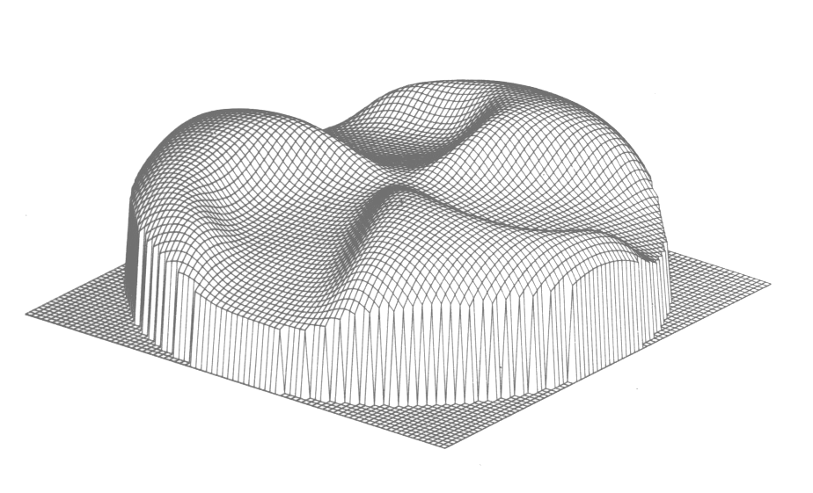
Notes on the ORIC Magnetic Field

Jim Ball July, 2003
Revised December, 2004

I. Introduction

Sector focusing in ORIC is provided by shaped magnetic pole tips separated by valleys that run from the center of the pole face to its perimeter. The ORIC magnetic field has three-fold symmetry so that each hill and valley is separated from the others by 120 degrees.
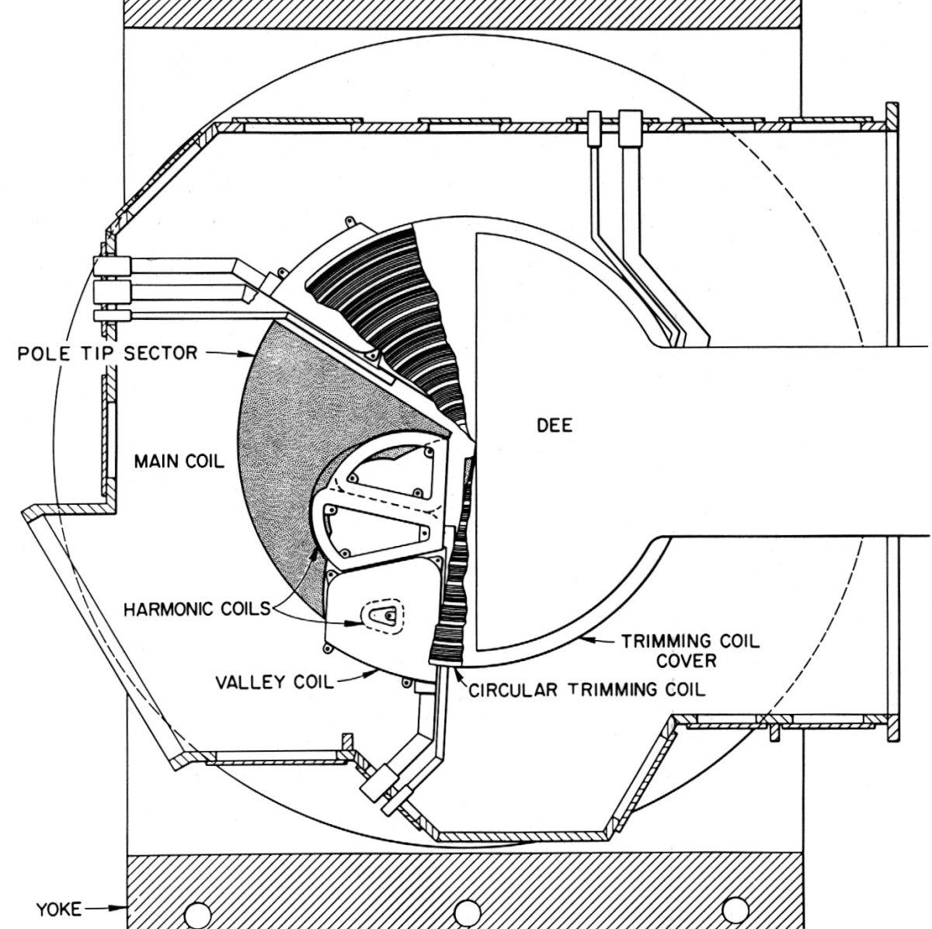
Lying in a "platter" immediately above the plane defined by the top of the pole tips are 10 concentric trimming coils. These trim coils provide the additional shaping capability, to the strength of the average field as a function of radius, needed to provide isochronous orbits for the particular particle and energy being accelerated.
There are four sets of coils, which occupy the three valleys between pole tips; three sets of harmonic coils (numbered 1 through 3 with increasing radius) and one set of valley coils. Facing ORIC from the Control Room side, the three valleys are at approximately 11, 3, and 7 o'clock, and are designated A, B, and C respectively.
Fig. 1. Layout of the Field-Shaping Coils in ORIC
It has been my impression that the harmonic coils were originally intended to be run in a polarity which added to the main field, and the valley coils were to run in a polarity that subtracted from the main field in the valley region. This increased "depth" of the field in the valley was intended to increase the amount of flutter required to provide focusing for the highest energy proton beams. I had also thought that with the changes in the RF system made as part of ORIC's conversion to a booster accelerator making acceleration of protons to high energy (> 55 MeV) no longer possible, it was decided that the use of the valley coils to increase flutter was no longer required. Hence the valley coils would be changed to the same polarity as the harmonic coils. The output of the ORIC orbit codes which were updated at that time, however, indicate that while the three sets of harmonic coils and the valley coils (now often referred to as harmonic-4) all now have the same polarity, the field contributions from these coils all subtract from the main field. The “negative” polarity of these coils has now been verified by a physical measurement (see References 1 and 2).

The ORIC coordinate system: In recent years it has become the convention to describe the layout of the ORIC magnetic and electrostatic components in terms of a radial coordinate system whose principal axis is horizontal, pointing towards the resonator. However, when ORIC was initially assembled, there was an extensive set of field measurements performed that utilized a coordinate system whose primary axis was selected to approximate the peak of the hill field for the pole tip associated with valley A. The principal axis of this "old" coordinate system corresponds to 63 degrees in the "new" coordinate system. A number of "features" of the ORIC internals measured in the "old" system are given in Table I along with the associated "new" coordinates.

Table I. ORIC Component Locations

Component | "Old" Coord. | "New" Coord. | "New" Coord.  Valley B | "New" Coord.  Valley C
Harmonic Coil A1 | 22° | 85° | 325° | 205°
Harmonic Coil A2 | 39° | 102° | 342° | 222°
Harmonic Coil A3 | 63° | 126° | 6° | 246°
Valley Coil A4 | 64° | 127° | 7° | 247°
Deflector Entrance | 32° | 95° | - - - | - - -
Deflector Exit | 88° | 151° | - - - | - - -
Straight edge of Pole Top C | 84° | 127° | - - - | - - -

The azimuthal "centers" of the harmonic and valley coils are taken from the field measurement plots in an unpublished report dated November 30, 1962, and the deflector coordinates are from ORNL 3630, p. 40 (Ref. 3). The pole tip orientation is taken from existing drawings.

II. Harmonic Coils

The harmonic coils provide the capability to adjust the first harmonic content of the magnetic field. This can be used either to cancel unwanted field perturbations introduced by magnet imperfections, by beam extraction elements, or by other magnetic components close the field. It can also be used to provide a controlled field harmonic to enhance orbit separation at the deflector entrance, or to do all of these simultaneously.
Each set of harmonic coils is operated as a unit so that changes to the magnitude and azimuth of the generated harmonic produces no net change on the contribution of this set to the average magnetic field. I.e., the average current in the three coils in the set must remain invariant. This condition is achieved by requiring that the projection of the harmonic vector on to each of the coil axis obey a cosine relationship. The required invariance is assured through the symmetry properties of the transcendental functions. In this case from the identity;

cosθ + cos(120 + θ) + cos(240 + θ) ≡ 0 (1)

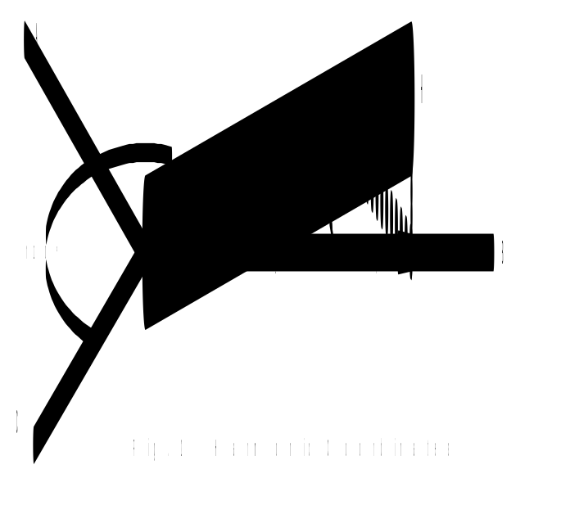The calculation of the current distribution in each coil set follows the relationship indicated in Figure 2. Here, the desired first harmonic to be produced by the harmonic coil set has a strength of H and is oriented at an azimuth defined by θ_{H}.
As illustrated in Figure 2, the projection of this harmonic "current" on the axis of the B harmonic coil is given by I_{B} = Hcosθ_{H}. (In all of these calculations we will deal with coil currents rather than magnetic field strength since, in the present range of interest, the field is directly proportional to current.)
A similar projection of the harmonic vector on the axis of the A and C axis results in the following expression for the total coil currents:

I_{tot} = I_{A} + I_{B} + I_{C} = Hcos(θ_{H}-120) Hcos(θ_{H}) + Hcos(θ_{H}-240)

= H[cos(θ_{H}-120) cosθ_{H} + cos(θ_{H}-240)] (2)

From equation (1), the quantity in the square brackets in equation (2) is equal to 0 (i.e., one or more of the calculated coil currents will be negative) so that the requirement for I_{tot} = 0 is satisfied. However, since we are working in a two-dimensional space and projecting on three axes, these projections will not be normalized. We can see this by calculating how much each coil current contributes to the resultant vector H. From Figure 2 we can see that the projection of I_{B} on H (dotted line) will be given by I_{B}cosθ_{H} = Hcos²θ_{H}. Thus the total projection of the current from the three coils back on the harmonic vector is:

I_{proj} = I_{A}cosθ_{H} + I_{B}cosθ_{H} + I_{C}cosθ_{H} = H[cos²(θ_{H}-120)+ cos²θ_{H} + cos²(θ_{H}-240)] (3)

It can be shown that for any value of θ, the value in the square brackets in equation (3) is identically equal to 1.5. Thus, projecting H on all three axes will result in currents that produce a harmonic vector that is 1.5 times the strength desired. We must thus normalize our calculation by multiplying each of the currents by a factor of 2/3. This normalization will not effect the result that I_{tot} = 0 for the average current in the coil set.
Note: The general formula for the normalization factor for harmonic coil currents is N = 2/n where n is the number of equal angle sectors in the magnetic field. I.e., for a four-sector machine the normalization factor will be 2/4 = ½. This is much easier to see intuitively than the three sector case, since projecting the harmonic vector onto four axes obviously overestimates the strength by a factor of 2.

As noted above, the average current of zero requires one or more coil currents to be negative. Since our power supplies are not bipolar, it is more convenient to operate these coil sets with a current offset that is larger than any negative current that could be required. This means that the offset current must be at least 2/3H. The resulting contribution of the field generated by this offset current to the main field must be compensated for with the trim coils. Thus the offset current should be chosen large enough to avoid retuning trim coils as the harmonic coils are adjusted.
An additional complication is that each set of harmonic coils has a set of coordinates that is rotated with respect to the coordinate axis of the cyclotron. These parameters are listed in Table I above.
Taking all of these factors into consideration, the algorithms for setting currents in each set of harmonic coils is given in Table II.

Table II. Harmonic Coil Algorithms

I_{A1} = OF₁ + ⅔AM₁cos(PH₁ – 85) I_{A3} = OF₃ + ⅔AM₃cos(PH₃ – 126)
I_{B1} = OF₁ + ⅔AM₁cos(PH₁ – 325) I_{B3} = OF₃ + ⅔AM₃cos(PH₃ – 6)
I_{C1} = OF₁ + ⅔AM₁cos(PH₁ – 205) I_{C3} = OF₃ + ⅔AM₃cos(PH₃ – 246)

I_{A2} = OF₂ + ⅔AM₂cos(PH₂ – 102) I_{A4} = OF₄ + ⅔AM₄cos(PH₄ – 127)
I_{B2} = OF₂ + ⅔AM₂cos(PH₂ – 342) I_{B4} = OF₄ + ⅔AM₄cos(PH₄ – 7)
I_{C2} = OF₂ + ⅔AM₂cos(PH₂ – 222) I_{C4} = OF₄ + ⅔AM₄cos(PH₄ – 247)

Here, the quantities OF_{x}, AM_{x}, and PH_{x} refer to the chosen offset and desired harmonic amplitude and azimuth (phase), respectively, for each coil set.

Unfortunately, the need to normalize these equations was not recognized at the time the ORIC control system was designed. Therefore, the equations used do not contain the factor of ⅔ shown in Table II. This error was also propagated into the ORIC orbit codes, so at least there is a consistent “inconsistency” with respect to these settings between the orbit code calculations and the control system settings (as long as the settings are specified in terms of amplitude and phase). At some point, it would be good to modify both the control system and the codes to use the correct equations.

III. Trim Coils

The ten concentric trim coils provide a positive contribution that increases from the center of the main field and peaks at approximately the inside radius of the coil. The general properties of these coils are listed in Table III. The data are also taken from the field measurements plots of the November 30, 1962, unpublished report. At the present time, trim coil 8 has 1/3 of its turns shorted out, and trim coils 9 and 10 are out of operation. The Valley coil set is also included in this table since, with trim coils 9 and 10 no longer operational, using the offset in this harmonic coil set provides the only field shaping control beyond about 25 inches. The practicality of this use for shaping the field profile is discussed a bit more below.

Table III Trim Coil Properties

Coil | Radius at  Peak Field (PF) | Fraction of  PF at 0 inches
Trim 1 | 0.0 inches | 1.00
Trim 2 | 4.0 inches | 0.98
Trim 3 | 8.0 inches | 0.91
Trim 4 | 11.5 inches | 0.78
Trim 5 | 15.0 inches | 0.70
Trim 6 | 18.5 inches | 0.62
Trim 7 | 22.0 inches | 0.58
Trim 8* | 25.0 inches | 0.23
(Trim 9) | (29.0 inches) | (0.49)
(Trim 10) | (32.0 inches) | (0.46)
Valley Harmonic | 33.0 inches | [½ PF at 25 inches]
*Trim coil number 8 has 1/3 of its turns shorted out

The trim coils are normally operated in the current range that will modify the strength of the main field by up to 200 gauss. While the valley coils produce a field change over a subtended angle of only about 24 degrees per coil, they can produce a modification of up to 2 kilogauss over this region. For the three coils, this amounts to an average field modification of 400 gauss. It is also interesting to note that this average field will fall to about half strength at 25 inches – just where the last active trim coil has its peak field. However, it needs to be noted that this strength of field from the valley coil set is achieved at a current in the valley coils of about 1800 amps. This is 4 times the current available from the present supplies. Nevertheless, the use of the offset current in the valley harmonics provides a viable alternative for shaping the isochronous profile of the magnetic field in the critical region near extraction.

IV. References
1. “Background study for Measuting Polarity of Harmonic and Valley Contributions to the ORIC Main Field Profile,” J. Ball, July 2004 (available on ORIC Programs CD).
2. “Experimental Determination of ORIC Harmonic Coil Polarities,” Jim Ball, Carl Dukes, Ed Hudson, Dick Lord, Alan Tatum, November 18, 2004 (available on ORIC Programs CD).
3. ORNL 3630, Electronuclear Division Annual Progress Report for Period Ending Dec. 31, 1963, pages 38 to 62.
.

